Advanced Programming Language

Assignment – 4

Chinmay Dorge

LCS2020022

Q1) Write a Package MCA, which has one class Student. Accept student detail through the parameterized constructor. Write display() method to display details. Create the main class that will use the package and calculates total marks and percentages.

Code:

student.java

package MCA;  
public class student{  
 public int rollNumber;  
 public String Name;  
 private int marks1 , marks2 , marks3;  
 private int sum ;  
 private double percentage;  
 public student(int roll , String name , int m1 , int m2 , int m3){  
 rollNumber = roll;  
 Name = name;  
 marks1 = m1;  
 marks2 = m2;  
 marks3 = m3;  
 sum = m1 + m2 + m3;  
 double temp = sum;  
 percentage = ((temp)/300d)*100d;  
 }  
 public void display(){  
 System.out.println("Student's Roll Number = " + rollNumber);  
 System.out.println("Student's Name = " + Name);  
 System.out.println();  
 System.out.println("Student's Marks for the 3 subjects: ");  
 System.out.println("Subject 1 = " + marks1);  
 System.out.println("Subject 2 = " + marks2);  
 System.out.println("Subject 3 = " + marks3);  
 System.out.println();  
 System.out.println("Total marks = " + sum);  
 System.out.println("Percentage = " + percentage);  
 }  
}

Main.java

import java.util.Scanner;  
import MCA.student;  
public class Main {  
 public static void main(String[] arg){  
 Scanner sc = new Scanner(System.in);  
 System.out.println("Enter Student's following details ");  
 System.out.print("Name: ");  
 String n = sc.nextLine();  
 System.out.print("Roll number: " );  
 int roll = sc.nextInt();  
  
 System.out.println("Enter marks of following subject (maximum marks for each is 100)");  
 System.out.print("Subject 1: ");  
 int a = sc.nextInt();  
 System.out.print("Subject 2: ");  
 int b = sc.nextInt();  
 System.out.print("Subject 3: ");  
 int c = sc.nextInt();  
  
 student s = new student(roll , n , a , b ,c);  
  
 s.display();  
 }  
}

Output:

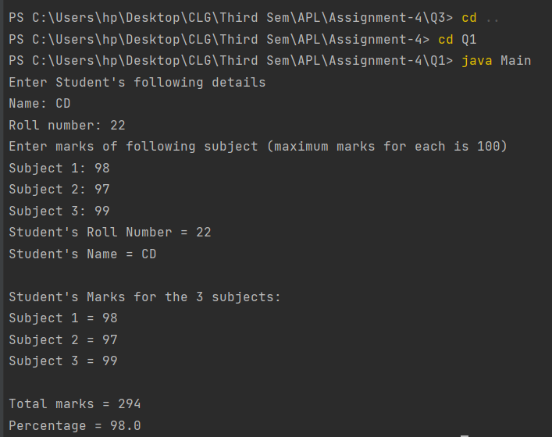

Q2) Write a program to create a user-defined package in Java called vehicle and include it in your program called car. Construct your program as if you are using inheritance, but via packages. Let your parent class be in the vehicle and let your subclass be in the car.

Code:

Vehicle.java

package vehicle;  
public class Vehicle {  
 protected int wheels;  
 protected String company, fuelType;  
  
 protected Vehicle(String company, String fuelType, int wheels) {  
 this.company = company;  
 this.fuelType = fuelType;  
 this.wheels = wheels;  
 }  
  
 protected void displayProperties() {  
 System.out.println("-------------------------------");  
 System.out.println("Company: " + company);  
 System.out.println("Fuel Type: " + fuelType);  
 System.out.println("Number of wheels: " + wheels);  
 System.out.println("-------------------------------");  
 }  
}

Car.java

package car;  
import vehicle.*;  
public class Car extends Vehicle{  
 public Car(String company, String fuelType){  
 super(company,fuelType,4);  
 }  
  
 public void displayProperties(){  
 System.out.println("Properties of this car: ");  
 super.displayProperties();  
 }  
}

Main.java

import car.Car;  
public class Main {  
 public static void main(String[] args){  
 Car obj = new Car("Tesla" , "Electricity");  
 obj.displayProperties();  
 }  
}

Output:

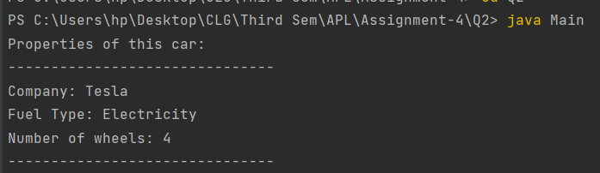

Q3) Create a package that consists of three public classes, one private and one protected class, and an interface. Each of the classes consists of at least two methods (set access specifiers of the methods as per your convenience) and the interface consists of three Abstract classes. Now create a main class that imports the above-mentioned package and displayed the functionality/results of the methods, which you have created.

Code:

A.java

package pack;  
  
import java.util.Scanner;  
  
interface Journey{  
 void setStart();  
 void setStop();  
 void setTotalTime();  
}  
public class A implements Journey{  
 private String name,Bplace,Tplace,time;  
  
 Scanner sc=new Scanner(System.in);  
 public void setName(String s){  
 this.name=s;  
 }  
 public String getName(){  
 return name;  
 }  
 public void setStart(){  
 System.out.println("Enter beginning place of journey: ");  
 Bplace=sc.nextLine();  
 }  
 public String getStart(){  
 return Bplace;  
 }  
 public void setStop(){  
 System.out.println("Enter terminating place of journey: ");  
 Tplace=sc.nextLine();  
 }  
 public String getStop(){  
 return Tplace;  
 }  
 public void setTotalTime(){  
 System.out.println("Enter total time of journey: ");  
 time=sc.nextLine();  
 }  
 public String getTotalTime(){  
 return time;  
 }  
}

B.java

package pack;  
  
public class B {  
 private String TrainName;  
  
 public void setTrainName(String s){  
 this.TrainName=s;  
 }  
 public String getTrainName(){  
 return TrainName;  
 }  
 private int cost;  
 protected void SetCost(int i) {  
 this.cost = i;  
  
 }  
  
 public int getCost() {  
 return cost;  
 }  
  
}

C.java

package pack;  
import java.util.Scanner;  
  
public class C extends B {  
 private int seat_no;  
 public void setSeatNo(int i){  
 this.seat_no=i;  
 }  
 public int getSeatNo(){  
 return seat_no;  
 }  
  
 public void InputDetails (A objA){  
 Scanner sc = new Scanner(System.in);  
 String s1, s2;  
 int u, v;  
 System.out.println("Enter your name: ");  
 s1 = sc.nextLine();  
  
 objA.setName(s1);  
 System.out.println("Enter train name: ");  
 s2 = sc.nextLine();  
 setTrainName(s2);  
 System.out.println("Enter seat no.: ");  
 u = sc.nextInt();  
 setSeatNo(u);  
 objA.setStart();  
 objA.setStop();  
 objA.setTotalTime();  
 System.out.println("Enter cost: ");  
 v = sc.nextInt();  
 SetCost(v);  
 System.out.println();  
 }  
  
}

Main.java

package Main;  
import pack.*;  
class Print{  
 private static class Ticket{  
 void print(){  
 System.out.println("----------TICKET----------");  
 }  
 }  
 void PrintTicket(){  
 Ticket t=new Ticket();  
 t.print();  
 }  
 protected static class HappyJourney{  
 void print_hj(){  
 System.out.println("Happy Journey :)");  
 System.out.println("--------------------------");  
 }  
 }  
 void PrintHappyJourney() {  
 HappyJourney hj = new HappyJourney();  
 hj.print_hj();  
 }  
  
}  
public class Main{  
 public static void main(String[] args) {  
 A objA=new A();  
 C objC=new C();  
 Print p=new Print();  
 objC.InputDetails(objA);  
 p.PrintTicket();  
 System.out.println("Name: "+objA.getName());  
 System.out.println("Train: "+objC.getTrainName());  
 System.out.println("From: "+objA.getStart());  
 System.out.println("To: "+objA.getStop());  
 System.out.println("Seat No: "+objC.getSeatNo());  
 System.out.println("Total time: "+objA.getTotalTime());  
 System.out.println("Cost: "+objC.getCost()+"₹");  
 p.PrintHappyJourney();  
 }  
}

Output:

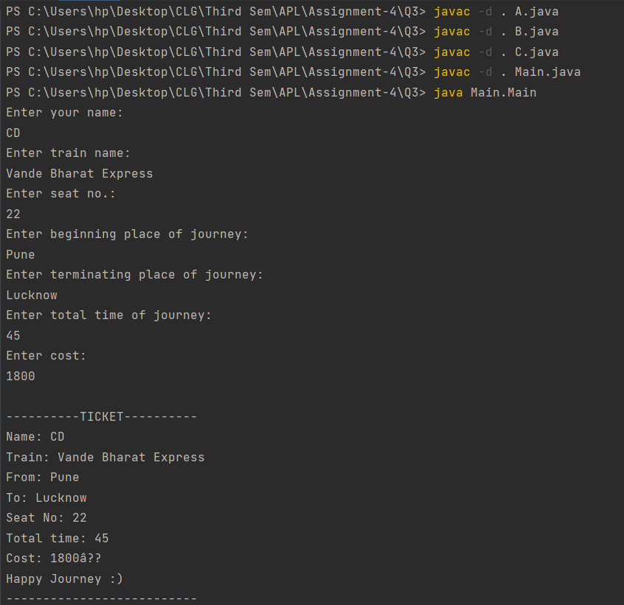

Q4) Write two classes, where first-class contains a sort method that sort the 10 numerical numbers and printed sorted sequence of the numbers and the second class contains a division method that consists of an array of 15 numbers, and each number is divided by a numerical number such as arr[]= {10, 20, 30} and the numerical number is 2, so the output of this array is {5, 10, 15}. To define the possible error handling mechanism for the above two classes and check how your code handled the exceptions.

Code:

ArrayDivide.java

import java.util.Arrays;  
  
public class ArrayDivide {  
 public static void divArray(int[] arr, int n) throws Exception {  
 if (arr.length != 15)  
 throw new IllegalArgumentException(  
 "Expected length of array is 15\nLenght of array recieved = " + arr.length);  
 for (int i=0;i<15;i++)  
 arr[i] /= n;  
 printArray(arr);  
 }  
  
 static public void printArray(int[] arr) {  
 System.out.println("Divided array:");  
 System.out.println(Arrays.toString(arr));  
 }  
  
 public static void main(String[] args) {  
 try {  
 ArrayDivide.divArray(new int[] { 1,2,3,4 }, 3);  
 } catch (Exception e) {  
 System.out.println(e);  
 }  
 System.out.println("--------------------------");  
 System.out.println();  
 try {  
 ArrayDivide.divArray(new int[] { 7, 14, 21, 28, 35, 42, 49, 56, 63, 70, 77, 84, 91, 98, 105 }, 7);  
 } catch (Exception e) {  
 System.out.println(e);  
 }  
 System.out.println("--------------------------");  
 }  
}

SortArray.java

import java.util.Arrays;  
  
public class SortArray {  
 public static void sorting(int[] arr) throws Exception {  
 if (arr.length != 10)  
 throw new IllegalArgumentException(  
 "Expected length of array is 10\nLenght of array recieved = " + arr.length);  
 Arrays.sort(arr);  
 printArray(arr);  
 }  
  
 static public void printArray(int[] arr) {  
 System.out.println("Sorted array:");  
 System.out.println(Arrays.toString(arr));  
 }  
  
 public static void main(String[] args) {  
  
 try {  
 SortArray.sorting(new int[] { 99, 5, 34, 1313 });  
 } catch (Exception e) {  
 System.out.println(e);  
 }  
 System.out.println("--------------------------");  
 try {  
 SortArray.sorting(new int[] { 5, 1, 88, 77, 65, 144, 54, 2, 99, 33 });  
 } catch (Exception e) {  
 System.out.println(e);  
 }  
 System.out.println("--------------------------");  
 }  
}

Output:

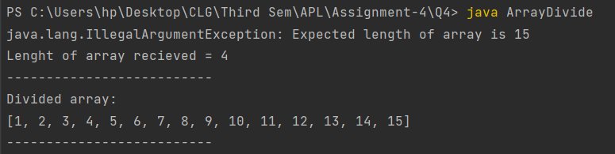

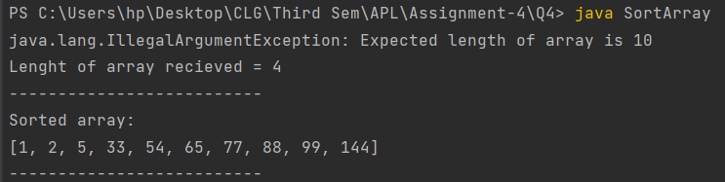

Q5) Create a package that consists of two public classes and one private class. Now create another main class that can access the methods of the package using the fully qualified name concept of the package and the import package.classname concept. In that case, write two separate java programs to show how fully qualified name concept of the package and the import package.classname concept works in java programming.

Code:

package1.java

package pack1;  
public class package1 {  
 public void getDetails(){  
 System.out.println("This is package 1");  
 }  
}

package2.java

package pack2;  
public class package2 {  
 public void getDetails(){  
 System.out.println("This is package 2");  
 }  
}

usingClassname.java

package Main;  
import pack1.package1;  
import pack2.package2;  
  
public class usingClassname{  
 public static void main(String[] args){  
 package1 p1 = new package1();  
 package2 p2 = new package2();  
  
 p1.getDetails();  
 p2.getDetails();  
 }  
  
}

usingFullyQualified.java

package Main;  
  
public class usingFullyQualified {  
 public static void main(String[] args){  
 pack1.package1 p1 = new pack1.package1();  
 pack2.package2 p2 = new pack2.package2();  
  
 p1.getDetails();  
 p2.getDetails();  
 }  
}

Output:

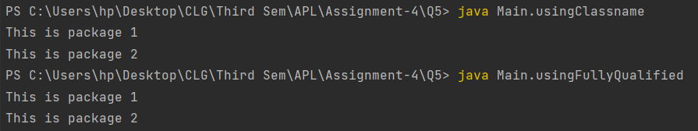

Q6) Prepare your own scenario and write a java program where you can use four java concepts together such as inheritance, interface, Abstract class, and package.

Code:

Travel.java

package A;  
//use of interface  
interface Date{  
 void setDate(String i);  
}  
  
public class Travel implements Date{  
 String date;  
 String destination;  
 public void setDate(String i){  
 this.date=i;  
 }  
 public String getDate() {  
 return date;  
 }  
  
 public void setDestination(String s){  
 this.destination=s;  
 }  
 public String getDestination() {  
 return destination;  
 }  
  
}

Main.java

package B;  
import A.Travel;//use of package.classname  
  
import java.util.Scanner;  
//use of abstract class  
abstract class Period{  
 abstract void setPeriod(String s);  
}  
//use of inheritance  
class Tour extends Period{  
 String period,Hotel;  
  
 public void setPeriod(String s){  
 this.period=s;  
 }  
 public String getPeriod() {  
 return period;  
 }  
 public void hotelAvailability(String s){  
 this.Hotel=s;  
 }  
 public String getHotel() {  
 return Hotel;  
 }  
  
}  
class InputDetails{  
 public void Input(Travel objA,Tour objB){  
 Scanner sc=new Scanner(System.in);  
 String p,a,d,date;  
 System.out.println("Enter Date: ");  
 date= sc.nextLine();  
 objA.setDate(date);  
 System.out.println("Enter Period: ");  
 p=sc.nextLine();  
 objB.setPeriod(p);  
 System.out.println("Enter Destination: ");  
 d=sc.nextLine();  
 objA.setDestination(d);  
 System.out.println("Enter nearby hotel availability: ");  
 a=sc.nextLine();  
 objB.hotelAvailability(a);  
 System.out.println();  
 }  
}  
public class Main {  
 public static void main(String[] args) {  
 Travel objA=new Travel();  
 InputDetails i=new InputDetails();  
 Tour objB=new Tour();  
 i.Input(objA,objB);  
  
 System.out.println("Alright so, Lets look out for what all we have got in this the tour");  
 System.out.println("Date Decided to travel: "+objA.getDate());  
 System.out.println("Period at which we will be ready to begin our journey: "+objB.getPeriod());  
 System.out.println("Destination planned: "+objA.getDestination());  
 System.out.println("Availability of nearby hotels to stay: "+objB.getHotel());  
 System.out.println("Make sure you have fun in this tour, by enjoying every moment :)");  
 }  
}

Output:

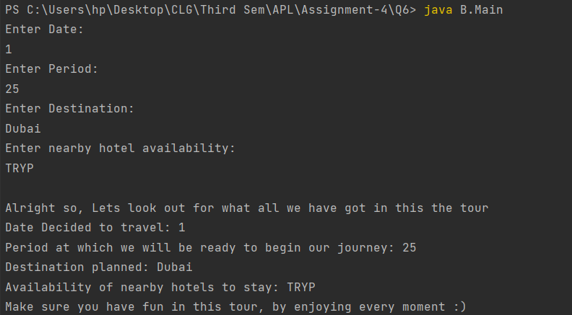

Note: The code is also sent in the zip and is available on GitHub. Repository link-

<https://github.com/Chinmay-Dorge/Advanced-Programming-Assignments>